Student’s Name
Professor’s Name
Course
August 31, 2020
Femininity and Masculinity

Idris Elba
Link: https://www.google.com/url?sa=i&url=https%3A%2F%2Fwww.theguardian.com%2Fculture%2F2018%2Faug%2F19%2Fidris-elba-my-ambition-is-boundless-yardie&psig=AOvVaw3-mk7h3smzkQDSJvJixK12&ust=1598978178960000&source=images&cd=vfe&ved=0CA0QjhxqFwoTCLCG_pHwxesCFQAAAAAdAAAAABAD
The gender performance being described from the photo of Idris Elba is his biological sex as a male. The image selected illustrates the male gender since it portrays masculinity alluding to the muscular, cheerful, tough, handsome, gentleman, nice, edgy, profound, mysterious certainty, dark, and gentle attributes. The traits align with Macey’s definition of a gendered male. Performing masculinity is highlighted in the image regarding how he is less likely to break another person’s heart or Elba’s ability to protect their loved ones from danger. From the Feminist Perspectives on Sex and Gender, Mackinnon reiterates, “I may have been influenced to find male dominance as appealing” (101).

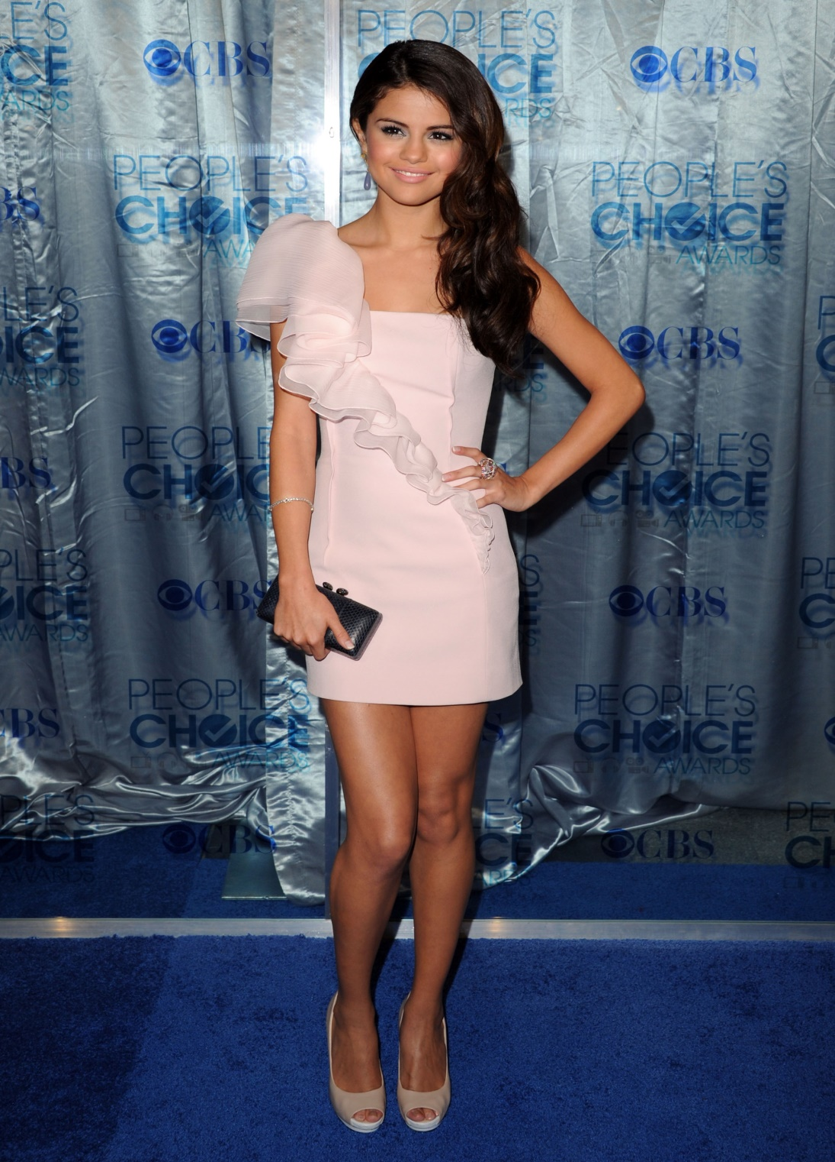
Selena Gomez Google Image
Link: https://www.google.com/url?sa=i&url=http%3A%2F%2Fwww.poshpoint.com%2Fstyle-profile-selena-gomez%2F&psig=AOvVaw04jtxPjsjkazg7JyshgWAq&ust=1598978344272000&source=images&cd=vfe&ved=0CA0QjhxqFwoTCLCh_OLwxesCFQAAAAAdAAAAABAE
Hyper-feminism is reflected in the image of Selena Gomez based on Macey’s definitions. Selena has gender performance evidenced by the image to depict her feminine self through the possession of a sweet and beautiful face, which is perceived as ideal. The picture demonstrates the female gender based on Selena’s beautiful complimented by her extravagant makeup, peach surroundings, and positioning on a purplish background. Her performing femininity is depicted from her dressing in a sexy dress while still maintaining a captivating look. She is a perfect embodiment of a young woman who strives for perfection but maintaining a non-aggressive and non-threatening self. She is portrayed as acting atypical gender role, which is analogous to her biological sex.
In addition, I am opined that my gender performance aligns with my sex. I consider myself feminine and do not have doubts that I am a proper female. I always strive to be meet feminine idealism from the way I dress, walk, and talk, eat, etc. Even though I uphold feminine tendencies, I do not discriminate against the other gender since I believe that the compelling differences are crucial to co-existence. My gender performance is culturally-inclusive since I always strive to achieve optimal decency. In doing so, I ensure that even persons from other cultures can appreciate my appearance. My sister played an integral part in my gender performance since I always strived to emulate her feminine mannerisms and outlook during my formative years. Besides, she always dressed me in beige, peach, and pink dresses when I was young. The norm of wearing clothes with female-oriented color has stuck despite being an adult now. I am comfortable with my gender performance, and I have no plans for changing it in the future. Social settings have influenced my gender performance since I come from a conservative neighborhood where people are judged based on their dressing and appearances. Thereby, my gender performance has always aligned with social expectations. My family has also played a significant role in my gender performance since dress codes need to adhere to alluding to my strict parents. Macey articulates the conflicts that exist between race and gender, “I understand when a person’s actual physical body doesn’t match with the gender they’ve been born into. That is clearly very difficult to navigate” (Macey 84).
Conclusively, I selected the image of Idris Elba to help elaborate on how he fosters gender performance in the context if a male. His traits align my perception of how males are or ought to be. Thus, I determined his positive and negative attributes based on my mental representation of males. I also chose Selena Gomez to reinforce the perception of feminism and female performance. The image was an ideal depiction of females in the modern world, alluding to their beautiful faces and perfect bodies embodied in their preference for specific colors. From a personal standpoint, I am opined that my gender performance is ideal regarding my biological sex, which is female. I am always striving for feminine perfection since it is something I want to achieve. Culturally, I have tailored my gender performance to ensure that it is acceptable to all cultures. In doing so, I perceive myself as a culturally-inclusive person. My sister, family, and social environments have played a significant role in molding my gender performance.
Part Two
One current event in the United States is guns being drawn at protest sites; thereby, there is a fear for a volatile social setting. U.S. cities have become unsafe since right-wing agencies are normally deployed to clash with the demonstrators. The security for protestors has become an imminent issue within the cities, especially in Portland. In this regard, there have been calls for protesters to use shields made of plywood or other materials to keep themselves safe. However, there have also been concerns about the need for shields against racial injustice during demonstrations. The precautions aim at protecting the protestors against premature death. The most notable protests around the country are “Black Lives” oriented.
There is always a likelihood of persistent confrontations between the demonstrators and the law enforcement officers during the protests. The results of the confrontations are normally lethal with tear gas canisters and lobbed projectiles being used. On the extreme end, the protests have started to become perilous since right-wing activities carry guns. The norm is based on the need to pass a message against racial injustice (Baker, Bosman, and Oppel Jr. n.p.). Therefore, violent street clashes are likely to emerge, causing some individuals to die. The phenomenon has sparked a debate on whether policing practice should be transformed to mitigate violence. President Trump has been critical that areas such as Kenosha have been uncontrollable in the past few weeks. For instance, three months ago, the death of George Floyd led opposite movements to brawl on the streets with no significant signs of owing up. Kenosha's situation erupted as a result of a police officer shooting a man of color known as Jacob Blake. The shooting fueled conflicts that led right-wing movements from Portland areas coming into the city to aid the retaliation efforts.

Works Cited
Baker, Mike, et al. “As Guns Get Drawn at Protest Sites, Demonstrators Fear a Volatile New
Phase.” The New York Times, 1 Sept. 2020, www.nytimes.com/2020/09/01/us/portland-kenosha-protests-clashes.html.
MacKinnon, S. Feminist Perspectives on Sex and Gender. Stanford Encyclopedia of Philosophy.
Sanford, California: University Press, 2006.
Macey, David. Penguin Dictionary of Critical Theory. Penguin: New York. 2000

